EXPERIMENT-16
- Implement a Sobel algorithm using Open CV to filter the input image.
a)CODE
import cv2
import os

img = cv2.imread(r"C:\Users\Varshini varshini\Desktop\photo.jpg")
if img is None:
print("Image not found! Check file path.")
else:
gray = cv2.cvtColor(img, cv2.COLOR_BGR2GRAY)
x = cv2.Sobel(gray, cv2.CV_64F, 1, 0, ksize=3)
y = cv2.Sobel(gray, cv2.CV_64F, 0, 1, ksize=3)
result = cv2.addWeighted(cv2.convertScaleAbs(x), 0.5,
cv2.convertScaleAbs(y), 0.5, 0)
desktop = os.path.join(os.path.expanduser("~"), "Desktop")
cv2.imwrite(os.path.join(desktop, "sobel_output.jpg"), result)
print("Output saved on Desktop!")
cv2.imshow("Sobel Output", result)
cv2.waitKey(0)
cv2.destroyAllWindows()

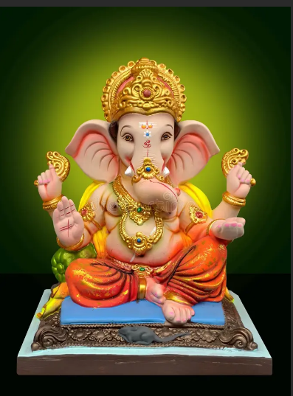
b) INPUT

- OUTPUT
